3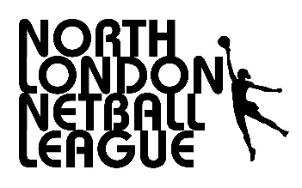North London Netball League
leaguesecretary@nlnl.co.uk

North London Netball League ( Lower League Div 7 - 10) : Confirmation of Details Form 2019/20 – GDPR compliance

A new General Data Protection Regulation (GDPR became law on the 25th May 2018). This law is aimed at protecting your personal data. Therefore, the North London Netball League will need your written consent to communicate with you (if you haven’t previously provided it) by e-mail, phone, text or by post.

Please complete and return this form, by 27th September, to the email address above marking the Subject Line GDPR. A copy of the NLNL Privacy Policy document is attached to the covering email. Please read the Privacy Policy document before providing your consent.

N.B. If your club has more than one contact/postholder who will need to communicate with the NLNL, for example, Club Secretary, Registrations Secretary, please provide the details for all contacts and fill in the consent boxes for each contact (if you haven’t previously done so).

CLUB : ……………………………………………………………….

NAME : ……………………………………………………………….

Role :………………………………………………………………..

Email : ……………………………………………………………….

Phone ……………………………………………………………….

NAME : ……………………………………………………………….

Role :………………………………………………………………..

Email : ……………………………………………………………….

Phone :……………………………………………………………….

Date……………
I/WE consent to you contacting me/us by (please tick appropriate boxes):

Name | email | phone | text | post

I/WE give the NLNL permission to use my/our contact details, for NLNL use only, as detailed in the NLNL Privacy Policy.

